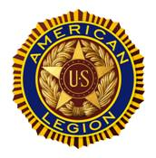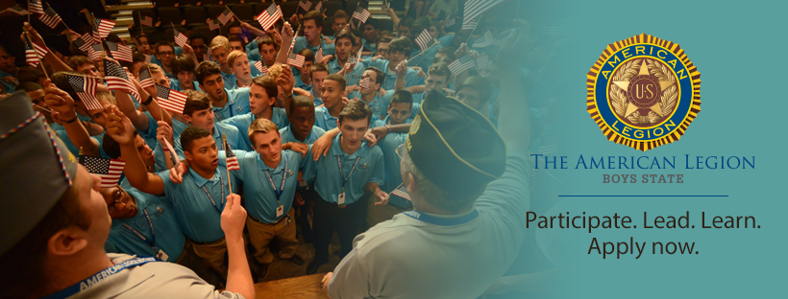
East Rochester American Legion Post 1917
Seeking Candidates for the 2024
American Legion Boys State of New York
The Boys State Program will take place from June 28th – July 3rd at SUNY Morrisville State College in Morrisville, New York.
This program is a true differentiator for college admissions, ROTC Scholarships, and Military Academies. This program teaches the working of government (local, county, and state) through practical hands-on exercises. You will learn leadership from those who were willing to risk their lives in defense of freedom. Boys State alumni include, for example, Bill Clinton, Michael Jordan, & George Pataki.
Eligibility requirements: *Must be in junior year of high school *Must have an 80% or “B” grade or higher of the male class *Should be attending East Rochester Junior-Senior High school
Candidates will be interviewed in January 2024. To apply contact Adam Laycock, 9-12 School Counselor (585-248-6337) Email: adam.laycock@erschools.org
For additional information go to: www.nylegion.net

